SIMATS ENGINEERING
ASSESSMENT TOOL 2

COURSE NAME: INTERNET PROGRAMMING
COURSE CODE: CSA43

COURSE OUTCOME COVERED

CO -2 : Apply CSS layout and styling techniques to create visually appealing and responsive web interfaces, and use JavaScript to enable interactive client-side behavior. (L3)

Assessment Tool : Design Task

Weightage: 20%

QUESTIONS: Total Marks: 20

Question 1: Responsive Navigation Bar Design - Marks(4)
Suppose that an e-commerce website requires a responsive navigation bar that adapts across desktop, tablet, and mobile devices.
(a) Identify key components required in a navigation bar for an e-commerce website.
(b) Design a responsive navigation bar using appropriate CSS techniques.
(c) Demonstrate how the navigation adapts to smaller screens (e.g., hamburger menu).
(d) Evaluate the usability and suggest improvements for better user experience.

Question 2: Product Hover Effect - Marks(4)
Suppose that an e-commerce website wants to enhance user interaction through visual effects on product items.
(a) Identify suitable CSS properties for hover effects.
(b) Suggest appropriate CSS animation or transition for product interaction.
(c) Design a hover effect for a product card.
(d) Evaluate performance and user experience considerations.

Question 3: Layout Selection (Flexbox vs Grid) - Marks(4)
Suppose that a dashboard layout needs to be designed for a web application.
(a) Identify layout requirements of a dashboard (rows, columns, alignment).
(b) Compare Flexbox and Grid based on layout needs.
(c) Choose the most suitable layout technique and justify your choice.
(d) Evaluate the scalability and responsiveness of the chosen approach.

Question 4: Mobile-First Blog Layout - Marks(4)
Suppose that a blog page must be designed following a mobile-first approach.
(a) Identify key sections of a blog layout.
(b) Design a mobile-first layout using CSS.
(c) Demonstrate how the layout scales for larger screens using media queries.
(d) Evaluate accessibility and readability of the design.

Question 5: JavaScript Event Handling for Dynamic Menu - Marks(4)
Suppose that a website includes a dynamic menu that responds to user interactions.
(a) Identify appropriate JavaScript events for menu interaction.
(b) Design event handling logic for menu toggle functionality.
(c) Implement interaction for user actions (click/hover).
(d) Evaluate performance and suggest improvements.

Code of Conduct:

I, Y. Sai Mohith (Reg No. 192372210), certify that this submission is my original work and that I have adhered to the guidelines specified for this assessment. I understand that any violation of academic integrity rules will result in disciplinary action.

Signature of the student: ____________________

RUBRICS FOR CALCULATION:

Criteria | Weightage (%) | Level 4 – Exemplary (4) | Level 3 – Proficient (3) | Level 2 – Developing (2) | Level 1 – Beginning (1)
Understanding of Concept | 25 | Demonstrates complete understanding of design requirements and concepts | Good understanding with minor gaps | Basic understanding with some errors | Poor understanding or incorrect concepts
Design / Implementation | 30 | Well-structured, efficient, and responsive design implementation | Correct implementation with minor issues | Basic implementation with inconsistencies | Incorrect or incomplete implementation
Use of Tools (CSS/JS) | 20 | Effective and advanced use of tools/techniques | Appropriate use of tools | Limited or inconsistent use | Incorrect or minimal use
Analysis & Evaluation | 15 | Insightful analysis with strong justification and optimization | Good analysis with justification | Basic analysis with limited depth | Poor or no analysis
Documentation / Clarity | 10 | Clear, well-structured, and properly presented solution | Mostly clear with minor issues | Basic clarity, missing details | Poor or unclear documentation

ANSWERS – CSA43 CO-2 DESIGN TASK
Student Name: Y. Sai Mohith
Register Number: 192372210
Question 1: Responsive Navigation Bar Design
(a) Key components include a logo, navigation links such as Home and Products, a cart indicator, and a menu toggle for mobile screens.
(b) CSS Flexbox aligns the logo, navigation links, and cart. Media queries adapt the navigation for smaller screens.
(c) On small screens, links are hidden and a hamburger button appears. Clicking it opens or closes the menu.
(d) Clear labels, visible cart information, and keyboard focus styles improve usability. A search box and account link could be added.
Question 2: Product Hover Effect
(a) Suitable CSS properties include transform, box-shadow, and background-color.
(b) A short transition lifts the product card and gently scales the product artwork.
(c) Each product card shows a name, description, price, and Add to Cart button. Clicking the button updates the cart count.
(d) Keep effects brief and lightweight, make content available without hovering, support keyboard focus, and respect reduced-motion preferences.
Question 3: Layout Selection (Flexbox vs Grid)
(a) A dashboard needs aligned metric cards, consistent gaps, and a full-width activity panel.
(b) Flexbox suits one-dimensional row or column layouts; Grid suits two-dimensional rows and columns.
(c) CSS Grid is suitable for the dashboard because it aligns cards into columns and lets the activity panel span a row. Flexbox aligns navigation items.
(d) Grid and media queries allow the number of columns to change on smaller screens, improving scalability and preventing horizontal scrolling.
Question 4: Mobile-First Blog Layout
(a) Main sections include a header/navigation, blog heading, article cards, titles, summaries, links, and footer.
(b) Start with a compact layout, readable text, and comfortable spacing for mobile screens.
(c) Media queries adjust the cards into multiple columns on larger screens and a compact or stacked layout on smaller screens.
(d) Use semantic headings, readable font sizes, descriptive links, sufficient contrast, visible keyboard focus, and responsive spacing.
Question 5: JavaScript Event Handling for Dynamic Menu
(a) Click events handle the hamburger menu, navigation links, Add to Cart buttons, and test button. CSS hover states can provide simple visual feedback.
(b) A click handler toggles an open class on the navigation menu and updates the aria-expanded attribute.
(c) Users can open or close the mobile menu, follow navigation links, add products to the cart, and click a test button to show a message.
(d) Keep event listeners simple and attach them once. Accessibility can be improved with Escape-key support and testing with screen readers.

APPENDIX: WEBSITE SCREENSHOTS AND SOURCE CODE
The following screenshots show the website implementation. The HTML, CSS and JavaScript source code is included below for reference.

Screenshot 1: Homepage and Navigation
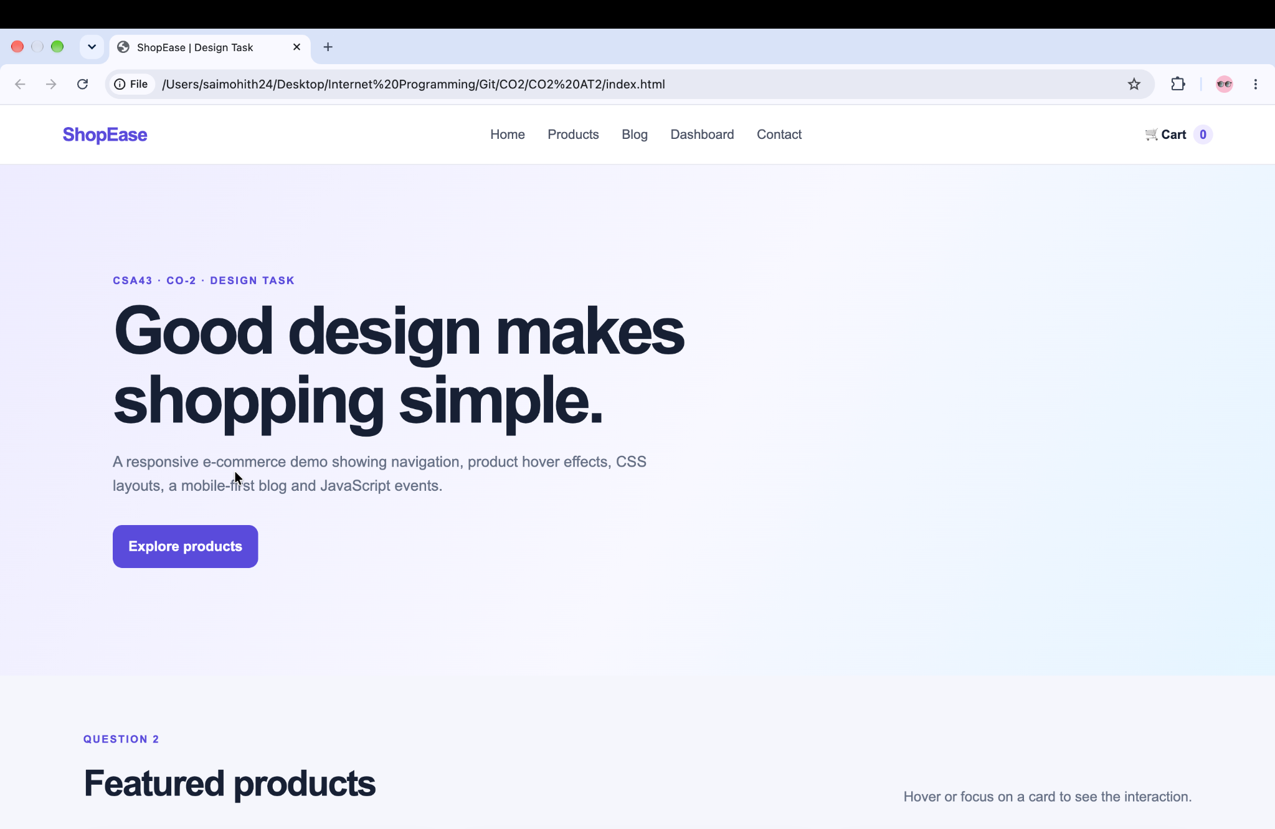

Screenshot 2: Product Cards and Cart Interaction
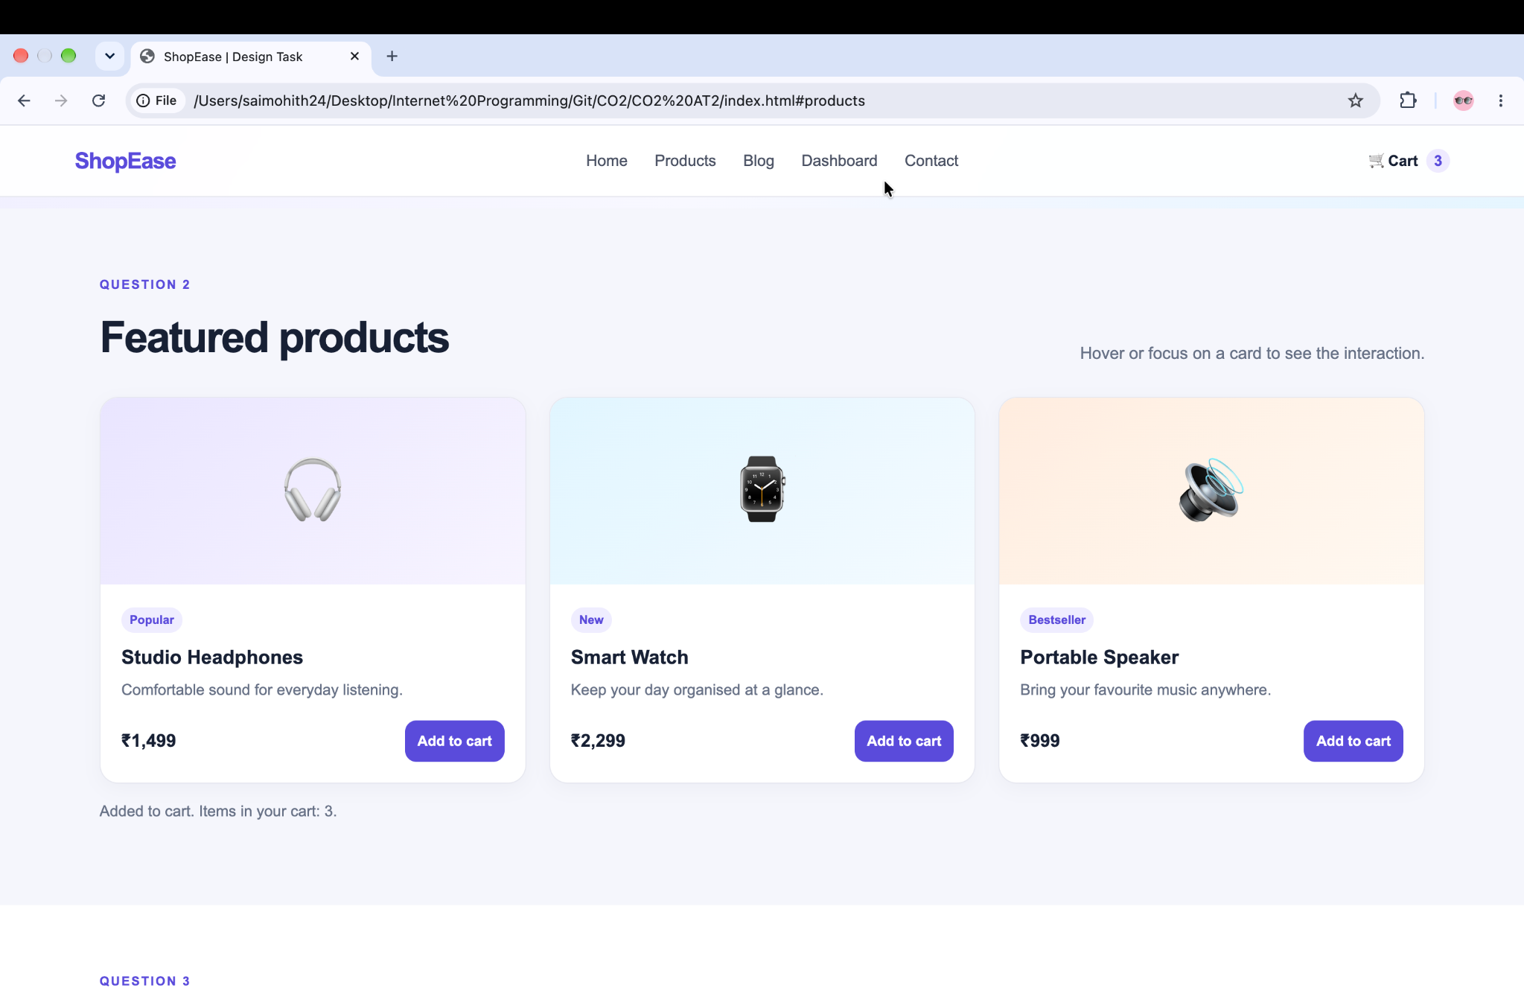

Source Code: index.html
<!DOCTYPE html>
<html lang="en">
<head>
<meta charset="UTF-8">
<meta name="viewport" content="width=device-width, initial-scale=1.0">
<title>ShopEase | Design Task</title>
<link rel="stylesheet" href="style.css">
</head>
<body>
<header class="site-header">
<a class="logo" href="#">ShopEase</a>
<button class="menu-toggle" id="menuToggle" aria-label="Toggle navigation"
aria-expanded="false" aria-controls="mainNav">☰</button>
<nav class="main-nav" id="mainNav">
<a href="#home">Home</a>
<a href="#products">Products</a>
<a href="#blog">Blog</a>
<a href="#dashboard">Dashboard</a>
<a href="#contact">Contact</a>
</nav>
<a class="cart" href="#products">🛒 Cart <span id="cartCount">0</span></a>
</header>
<main>
<section class="hero" id="home">
<p class="eyebrow">CSA43 · CO-2 · DESIGN TASK</p>
<h1>Good design makes shopping simple.</h1>
<p>A responsive e-commerce demo showing navigation, product hover effects, CSS layouts, a mobile-first blog and JavaScript events.</p>
<a class="primary-btn" href="#products">Explore products</a>
</section>
<section class="section" id="products">
<div class="section-heading">
<div><p class="eyebrow">QUESTION 2</p><h2>Featured products</h2></div>
<p>Hover or focus on a card to see the interaction.</p>
</div>
<div class="product-grid">
<article class="product-card">
<div class="product-art headphones" aria-hidden="true">🎧</div>
<div class="product-info"><span class="tag">Popular</span><h3>Studio Headphones</h3><p>Comfortable sound for everyday listening.</p><div class="product-bottom"><strong>₹1,499</strong><button class="add-btn">Add to cart</button></div></div>
</article>
<article class="product-card">
<div class="product-art watch" aria-hidden="true">⌚</div>
<div class="product-info"><span class="tag">New</span><h3>Smart Watch</h3><p>Keep your day organised at a glance.</p><div class="product-bottom"><strong>₹2,299</strong><button class="add-btn">Add to cart</button></div></div>
</article>
<article class="product-card">
<div class="product-art speaker" aria-hidden="true">🔊</div>
<div class="product-info"><span class="tag">Bestseller</span><h3>Portable Speaker</h3><p>Bring your favourite music anywhere.</p><div class="product-bottom"><strong>₹999</strong><button class="add-btn">Add to cart</button></div></div>
</article>
</div>
<p class="status-message" id="cartMessage" aria-live="polite">Your cart is empty.</p>
</section>
<section class="section dashboard-section" id="dashboard">
<div class="section-heading"><div><p class="eyebrow">QUESTION 3</p><h2>Store dashboard</h2></div><p>CSS Grid is useful for two-dimensional layouts.</p></div>
<div class="dashboard-grid">
<article class="metric"><span>Orders today</span><strong>128</strong><small>+12% this week</small></article>
<article class="metric"><span>Revenue</span><strong>₹42.8K</strong><small>Sales summary</small></article>
<article class="metric"><span>Customers</span><strong>864</strong><small>Active shoppers</small></article>
<article class="dashboard-panel"><h3>Recent activity</h3><ul><li>New order received <span>2 min ago</span></li><li>Product stock updated <span>18 min ago</span></li><li>Customer registered <span>32 min ago</span></li></ul></article>
</div>
</section>
<section class="section blog-section" id="blog">
<div class="section-heading"><div><p class="eyebrow">QUESTION 4</p><h2>From the blog</h2></div><p>Mobile-first layout: one column first, more columns on wider screens.</p></div>
<div class="blog-grid">
<article class="blog-card"><div class="blog-art art-one">01</div><div class="blog-copy"><p class="eyebrow">BUYING GUIDE</p><h3>How to choose everyday headphones</h3><p>Look for comfort, battery life, and sound that suits your listening habits.</p><a href="#contact">Read article →</a></div></article>
<article class="blog-card"><div class="blog-art art-two">02</div><div class="blog-copy"><p class="eyebrow">SMART LIVING</p><h3>Small tech upgrades that help</h3><p>Simple devices can make routines easier when they solve a real need.</p><a href="#contact">Read article →</a></div></article>
</div>
</section>
<section class="section interaction-section" id="contact">
<p class="eyebrow">QUESTION 5</p><h2>Try the dynamic menu</h2>
<p>Use the menu button on mobile, or activate the links with a keyboard. This demo uses click events and accessible state attributes.</p>
<button class="primary-btn" id="demoButton">Test JavaScript event</button>
<p id="demoMessage" class="status-message" aria-live="polite">Waiting for interaction…</p>
</section>
</main>
<footer><a class="logo" href="#home">ShopEase</a><p>Internet Programming · CSA43 · CO-2 Design Task</p></footer>
<script src="script.js"></script>
</body>
</html>

Source Code: style.css
/* Question 1: responsive navigation bar */
:root{--ink:#172033;--muted:#667085;--brand:#5b4bdb;--brand-dark:#4435b8;--surface:#fff;--page:#f5f6fb;--line:#e7e8f0;--radius:18px}
*{box-sizing:border-box}
html{scroll-behavior:smooth;scroll-padding-top:80px}
body{margin:0;font-family:Arial,Helvetica,sans-serif;color:var(--ink);background:var(--page);line-height:1.6}
a{color:inherit;text-decoration:none}
button{font:inherit;cursor:pointer}
.site-header{position:sticky;top:0;z-index:10;display:flex;align-items:center;gap:24px;padding:14px clamp(16px,5vw,72px);background:rgba(255,255,255,.96);border-bottom:1px solid var(--line);backdrop-filter:blur(12px)}
.logo{font-size:1.35rem;font-weight:800;letter-spacing:-.04em;color:var(--brand)}
.main-nav{display:flex;align-items:center;gap:22px;margin:auto}
.main-nav a{font-size:.94rem;color:#4a5264;padding:8px 2px}
.main-nav a:hover,.main-nav a:focus-visible{color:var(--brand)}
.cart{font-size:.9rem;font-weight:700;white-space:nowrap}
.cart span{display:inline-grid;place-items:center;min-width:23px;height:23px;margin-left:4px;border-radius:50%;background:#eeeaff;color:var(--brand)}
.menu-toggle{display:none;border:1px solid var(--line);background:white;border-radius:10px;padding:7px 11px;font-size:1.2rem}
.hero{padding:clamp(64px,10vw,124px) clamp(20px,9vw,130px);background:linear-gradient(120deg,#eeecff,#f8f8ff 55%,#e5f5ff)}
.hero h1{max-width:740px;margin:8px 0 16px;font-size:clamp(2.5rem,6vw,4.8rem);line-height:1.04;letter-spacing:-.055em}
.hero>p:not(.eyebrow){max-width:650px;color:var(--muted);font-size:1.08rem}
.eyebrow{margin:0 0 8px;color:var(--brand);font-size:.75rem;font-weight:800;letter-spacing:.13em}
.primary-btn,.add-btn{display:inline-flex;align-items:center;justify-content:center;border:0;border-radius:11px;background:var(--brand);color:white;font-weight:700;padding:12px 18px;transition:background .2s,transform .2s}
.primary-btn{margin-top:14px}
.primary-btn:hover,.add-btn:hover{background:var(--brand-dark);transform:translateY(-1px)}
.section{padding:64px clamp(20px,7vw,96px)}
.section-heading{display:flex;justify-content:space-between;align-items:end;gap:24px;margin-bottom:24px}
.section-heading h2,.interaction-section h2{margin:0;font-size:clamp(1.8rem,4vw,2.6rem);letter-spacing:-.04em}
.section-heading>p,.interaction-section>p:not(.eyebrow){max-width:430px;color:var(--muted);margin-bottom:5px}
.product-grid{display:grid;grid-template-columns:repeat(3,minmax(0,1fr));gap:22px}
.product-card{overflow:hidden;background:var(--surface);border:1px solid var(--line);border-radius:var(--radius);box-shadow:0 5px 18px rgba(29,33,65,.04);transition:transform .25s ease,box-shadow .25s ease}
.product-card:hover,.product-card:focus-within{transform:translateY(-7px);box-shadow:0 16px 34px rgba(29,33,65,.12)}
.product-art{display:grid;place-items:center;min-height:180px;font-size:4rem;transition:transform .25s ease}
.product-card:hover .product-art{transform:scale(1.06)}
.headphones{background:linear-gradient(135deg,#e9e5ff,#f7f4ff)}.watch{background:linear-gradient(135deg,#e1f5ff,#f4fbff)}.speaker{background:linear-gradient(135deg,#ffeddf,#fff8f1)}
.product-info{padding:20px}.tag{display:inline-block;padding:3px 8px;background:#f0edff;color:var(--brand);border-radius:20px;font-size:.72rem;font-weight:700}
.product-info h3{margin:9px 0 4px}.product-info p{color:var(--muted);font-size:.92rem;margin:0 0 18px}.product-bottom{display:flex;align-items:center;justify-content:space-between;gap:10px}.product-bottom strong{font-size:1.08rem}.add-btn{padding:9px 12px;font-size:.85rem}
.status-message{color:var(--muted);font-size:.92rem;min-height:1.5em}
.dashboard-section{background:#fff}.dashboard-grid{display:grid;grid-template-columns:repeat(3,minmax(0,1fr));gap:18px}
.metric,.dashboard-panel{padding:22px;border:1px solid var(--line);border-radius:var(--radius);background:#fff}
.metric{display:flex;flex-direction:column;gap:5px}.metric span,.metric small{color:var(--muted)}.metric strong{font-size:2rem;letter-spacing:-.04em}.metric small{color:#25815d}
.dashboard-panel{grid-column:1/-1}.dashboard-panel h3{margin:0 0 10px}.dashboard-panel ul{list-style:none;padding:0;margin:0}.dashboard-panel li{display:flex;justify-content:space-between;gap:14px;padding:11px 0;border-top:1px solid var(--line)}.dashboard-panel li span{color:var(--muted);font-size:.88rem}
.blog-grid{display:grid;grid-template-columns:repeat(2,minmax(0,1fr));gap:22px}.blog-card{display:grid;grid-template-columns:.8fr 1.2fr;overflow:hidden;background:#fff;border:1px solid var(--line);border-radius:var(--radius)}.blog-art{display:grid;place-items:center;min-height:210px;font-size:3rem;font-weight:800;color:#fff}.art-one{background:linear-gradient(140deg,#7766e8,#b1a6ff)}.art-two{background:linear-gradient(140deg,#198ca5,#9be3e6)}.blog-copy{padding:22px}.blog-copy h3{margin:5px 0 8px;line-height:1.25}.blog-copy p:not(.eyebrow){font-size:.92rem;color:var(--muted)}.blog-copy a{font-weight:700;color:var(--brand)}
.interaction-section{background:#eeecff}.interaction-section .status-message{color:#4435b8}
footer{display:flex;justify-content:space-between;align-items:center;gap:20px;padding:24px clamp(20px,7vw,96px);background:#fff;border-top:1px solid var(--line)}footer p{font-size:.85rem;color:var(--muted)}
a:focus-visible,button:focus-visible{outline:3px solid #8c80ff;outline-offset:3px}
@media(max-width:800px){.site-header{gap:12px;flex-wrap:wrap}.menu-toggle{display:block;margin-left:auto}.cart{order:2}.main-nav{display:none;order:3;flex-basis:100%;align-items:stretch;flex-direction:column;gap:2px;margin:0;padding:8px 0}.main-nav.open{display:flex}.main-nav a{padding:10px 8px;border-radius:8px}.main-nav a:hover{background:#f2f0ff}.product-grid{grid-template-columns:repeat(2,minmax(0,1fr))}.blog-card{grid-template-columns:1fr}.blog-art{min-height:130px}}
@media(max-width:560px){.section-heading{align-items:start;flex-direction:column;gap:8px}.product-grid,.dashboard-grid,.blog-grid{grid-template-columns:1fr}.dashboard-panel{grid-column:auto}.product-art{min-height:150px}.blog-card{grid-template-columns:.7fr 1.3fr}.blog-art{min-height:100%}footer{align-items:flex-start;flex-direction:column;gap:5px}.hero h1{font-size:2.7rem}}
@media(prefers-reduced-motion:reduce){*,*::before,*::after{scroll-behavior:auto!important;transition:none!important;animation:none!important}}

Source Code: script.js
// Question 5: JavaScript event handling for a dynamic menu
const menuToggle = document.getElementById("menuToggle");
const mainNav = document.getElementById("mainNav");
menuToggle.addEventListener("click", () => {
const isOpen = mainNav.classList.toggle("open");
menuToggle.setAttribute("aria-expanded", String(isOpen));
menuToggle.textContent = isOpen ? "✕" : "☰";
});
// Close the mobile menu after a navigation link is selected.
mainNav.querySelectorAll("a").forEach((link) => {
link.addEventListener("click", () => {
mainNav.classList.remove("open");
menuToggle.setAttribute("aria-expanded", "false");
menuToggle.textContent = "☰";
});
});
// Question 2: add-to-cart click events update the cart count.
let cartCount = 0;
const cartCountLabel = document.getElementById("cartCount");
const cartMessage = document.getElementById("cartMessage");
document.querySelectorAll(".add-btn").forEach((button) => {
button.addEventListener("click", () => {
cartCount += 1;
cartCountLabel.textContent = String(cartCount);
cartMessage.textContent = `Added to cart. Items in your cart: ${cartCount}.`;
button.textContent = "Added ✓";
window.setTimeout(() => { button.textContent = "Add to cart"; }, 900);
});
});
// Question 5: demonstrate a simple JavaScript click event.
document.getElementById("demoButton").addEventListener("click", () => {
document.getElementById("demoMessage").textContent =
"Success! The click event was handled by JavaScript.";
});

